HostsPro

Gage Price

CST-452 Capstone Project Requirements Document

Grand Canyon University

Instructor: Professor Mark Reha

Revision: 2.0

Date: 03/12/2025

**ABSTRACT**

This project is an application to organize the Microsoft host’s file. The hosts file in the file explorer is a normal text file which contains host names and their corresponding IP addresses. With this file you can override DNS for defined domains on a computer. This file has little structure, the constraints for entries is limited to one line per entry, spaces sperate the domain name and IP address, and comments are created using the pound symbol. The task for this project is to create an application that provides a simple and clean user interface for the user. The user will be able to enter their desired name server and their specified host name. My program will run a background search for the IP address of the name server provided. The program will then use that IP address and note where it points to by storing a comment of the name sever entered. They can activate or deactivate an entry with a click of a button.

For the average person this file is never used, but for some developers this file is used a lot in testing. Others use this file to block websites and set restrictions on what website a device can access. This file editor interface will make their work a whole lot easier, simpler, cleaner, and more organized.

|  |
| --- |
| History and Signoff Sheet |

**Change Record**

|  |  |  |
| --- | --- | --- |
| **Date** | **Author** | **Revision Notes** |
| 10/11/2024 | Gage Price | Initial draft for review/discussion |
| 03/12/2025 | Gage Price | Updates from development |
|  |  |  |

|  |
| --- |
| **Overall Instructor Feedback/Comments** |

|  |
| --- |
| **Overall Instructor Feedback/Comments** |

**Integrated Instructor Feedback into Project Documentation**

Yes  No

**TABLE OF CONTENTS**

Functional Requirements 4

Non-Functional Requirements 5

Technical Requirements 6

Logical System Design 7

User Interface Design 8

Reports Design 9

Functional Requirements

**Use Cases**

The functional use cases for this application describe what a user will be able to do, as well as what the system should be able to do.

See the attached Excel file “HostsPro Requirements” to view the functional user stories.

Non-Functional Requirements

**Use Cases**

The non-functional use cases for this application describe additional metrics that the application should be able to achieve.

See the attached Excel file “HostsPro Requirements” to view the non-functional user stories.

Technical Requirements

The technical requirements for this application are going to be the resources tools, technologies, and versions that will be used by the application, as well as during the creation of this application.

See the attached Excel file “HostsPro Requirements” to view the technologies.

Logical System Design

Below is the logical system diagram for the HostsPro application. The main display window is what the user will see. Data will come from the systems hosts.exe file and command prompt commands. This data will be sent through the application and then displayed to the main display window. Data will also pass from the display window to the application where it passes that data back down to the hosts.exe file or command prompt.

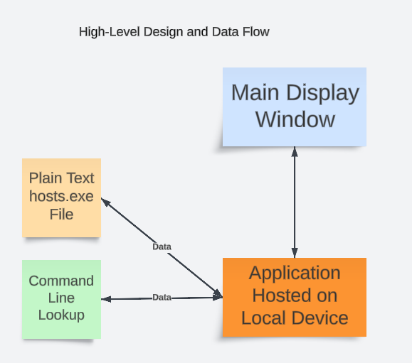

User Interface Design

Below is a diagram showing what will be displayed to the user. This application will only have one page. All round cells will be editable, and on save those changes will be applied. The red error popup in the top right will be displayed if there was a problem saving the to the file. In the last line you can see red text, which is how the user will know if their “Routes To” location is invalid.

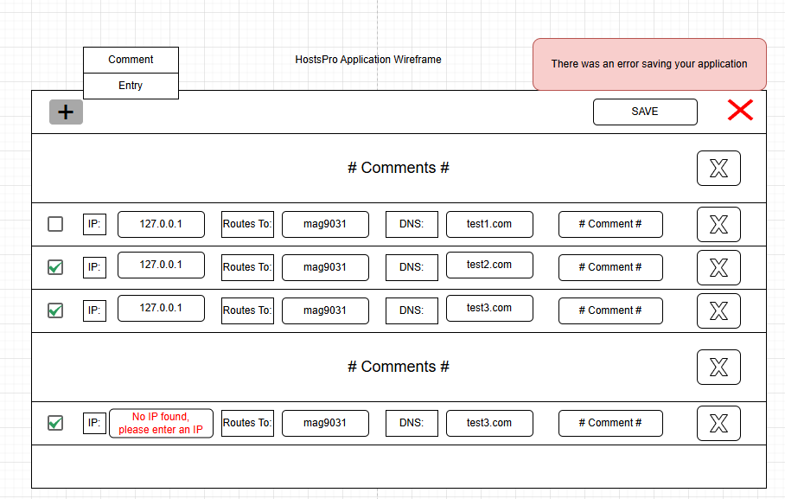

**Reports Design**

Not applicable.